POC Note: In the provided screenshots, we can see that an external URL was supplied in the frontendUrl parameter to load the frontend page and the request was sent to the server to save this value.

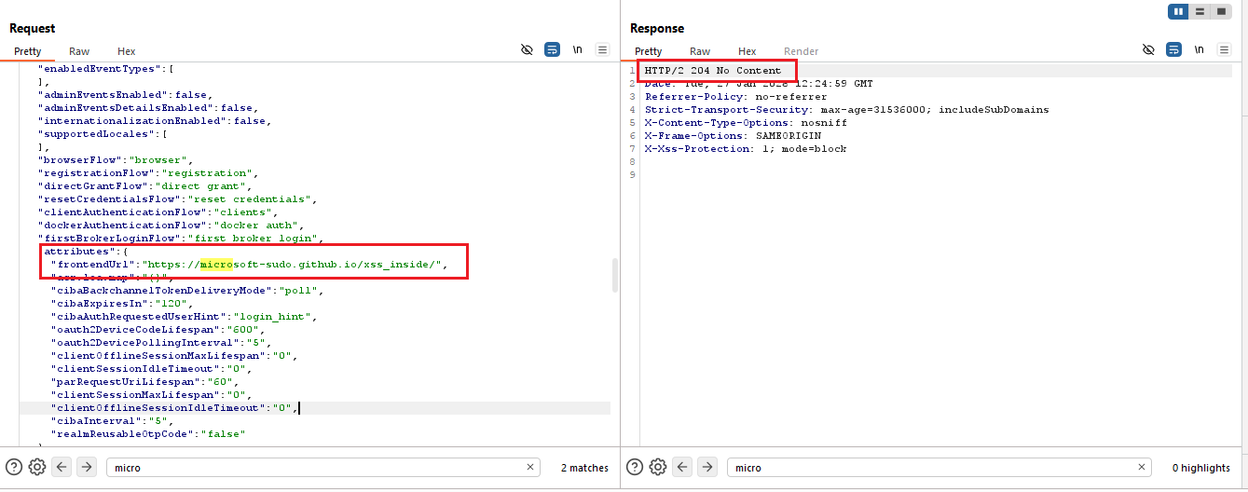
Image 1: Supplied External URL In FrontendUrl Parameter

After reloading the application, an error message appears with a “Back to Application” redirection option.

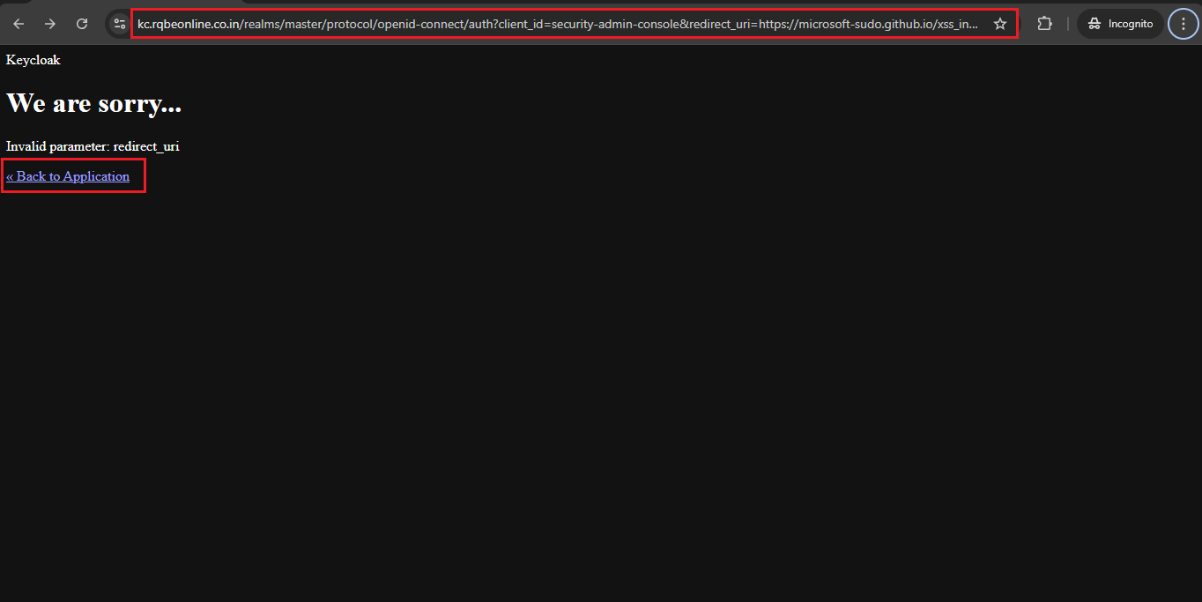
Image 2: Get Error Page with Redirection Option

When we click on the redirect button, the application redirects the user to an attacker-controlled webpage.

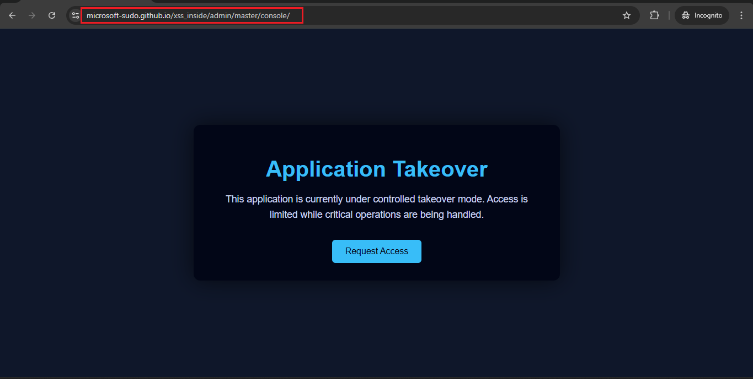
Image 3: User Get Redirected to Attacker Control Page

